

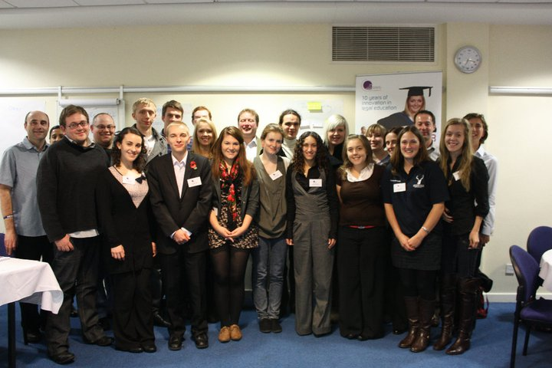
Photograph by Felicia Kyrk
The National Law Students Forum
3-4 November 2010
Manchester Conference Centre

Report by
Hannah Mallin, Undergraduate Student
Lancaster University Law School

Introduction
The talk on effective representation by a representative of the NUS made me realise that there are many different ways of getting students views across to the staff. We discussed informal engagement with staff and some interesting ideas were mentioned that I would never have thought of such as; a common room for lecturers and students to meet informally, inviting staff to social events and learning about the interests of the staff. I think it would be a good idea for the students and staff at my university to meet on a more informal basis as it would help us to understand each other and might make students less apprehensive about speaking to staff.
Support for students
Following on from the talk, we were then split up into groups and each given a problem. My group discussed support for students. A very interesting idea that was mentioned was for first year students to be given a final year mentor who they could go to for advice. A number of the group said that their universities used this scheme and they felt that it was a help for new students to be able to talk to someone nearer their own age about their problems. All of our universities have academic advisor system but some met regularly and socialised with their tutors whilst others had barley seen their advisor. I think that for the system to be effective students do need to see their academic advisor regularly, as they will get to know them and feel less inhibited about discussing problems with them. One university had had a law school social in Freshers Week and felt that this was a good idea as it had helped them to make friends so that they would have someone to discuss work issues with later on in the term. We discussed how to offer greater support to mature and foreign students. We thought that they could meet up as a group to get to know each other but should integrate with other students in seminars. It can be difficult for mature students to socialise at night as many have families and live off campus so we thought law schools could organise more socials during the day.
Quality of teaching
My group discussed how to improve the quality of teaching. We thought that better use could be made of technology such as; PowerPoints and podcasts of the lecture. We were satisfied with the amount of contact time that we receive but felt that they could sometimes be too much like a lecture and that greater student participation was needed and that a topic should be discussed in more depth rather than just a re-cap of the lecture. Different types of learning were discussed such as mooting and role play.
Communication and negotiation skills
The communication and negotiation skills workshop with Rebecca Huxley-Binns, the Law teacher of the year, was excellent and has given me a great deal to think about for the future. I realised the importance of presenting a good image through body language and skills and that networking will be essential for a career in law. We were given a contract scenario and had to negotiate the issues that had arisen in pairs. This exercise highlighted the importance of planning.
We were given scenarios about issues that could affect students, such as coursework marking. We had to work out what, as student representatives, we would say to the staff we were meeting with. Two members of the group then acted out the scenario with other students posing as staff. This was a really useful exercise in negotiating with staff and taught me how to formulate a reasoned argument instead of demands and criticism.
Law societies
During the conference we discussed our law societies and I felt that some seemed to be more active than others. Some universities held regular careers fairs and networked with or were sponsored by magic circle firms. I feel that this is important as it can be hard for students to make contact on their own. There were a variety of activities such as working with the police and prisons, a student newspaper and client negotiating competitions. Some societies kept in touch with past students who would come back to give careers advice. We felt that more support should be given to those who do not want to pursue a career in law.

Conclusion
The conference was an excellent experience and I feel that I have learned skills that will help me in my career and ideas that will help my fellow students. Personally, I feel more confident about speaking to staff and have learned how to negotiate and not just to criticise or demand. I have a number of recommendations to make to my law school. I feel that the student mentor scheme would be a great help to first year students as some students can feel apprehensive about talking to a member of staff. I think it would also be a good idea for students to meet more often with their academic advisor, a minimum of once a term, then they would really get to know them and feel more comfortable about asking them for advice. I feel that the student representatives should be more active in asking for opinions from their fellow students and that there should be a student discussion after each module has finished.

